- Download the Band APP from Apple or Google Play Store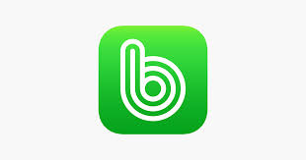

- Create a free account

- In the search bar at the top, search for DCMS Band

- Click on the image that pops up. At the bottom of the page, you should see a green logo that says “Join this Band,” click that.

- You will be approved to join by an admin.

- Congratulations! You are now subscribed to our Band!
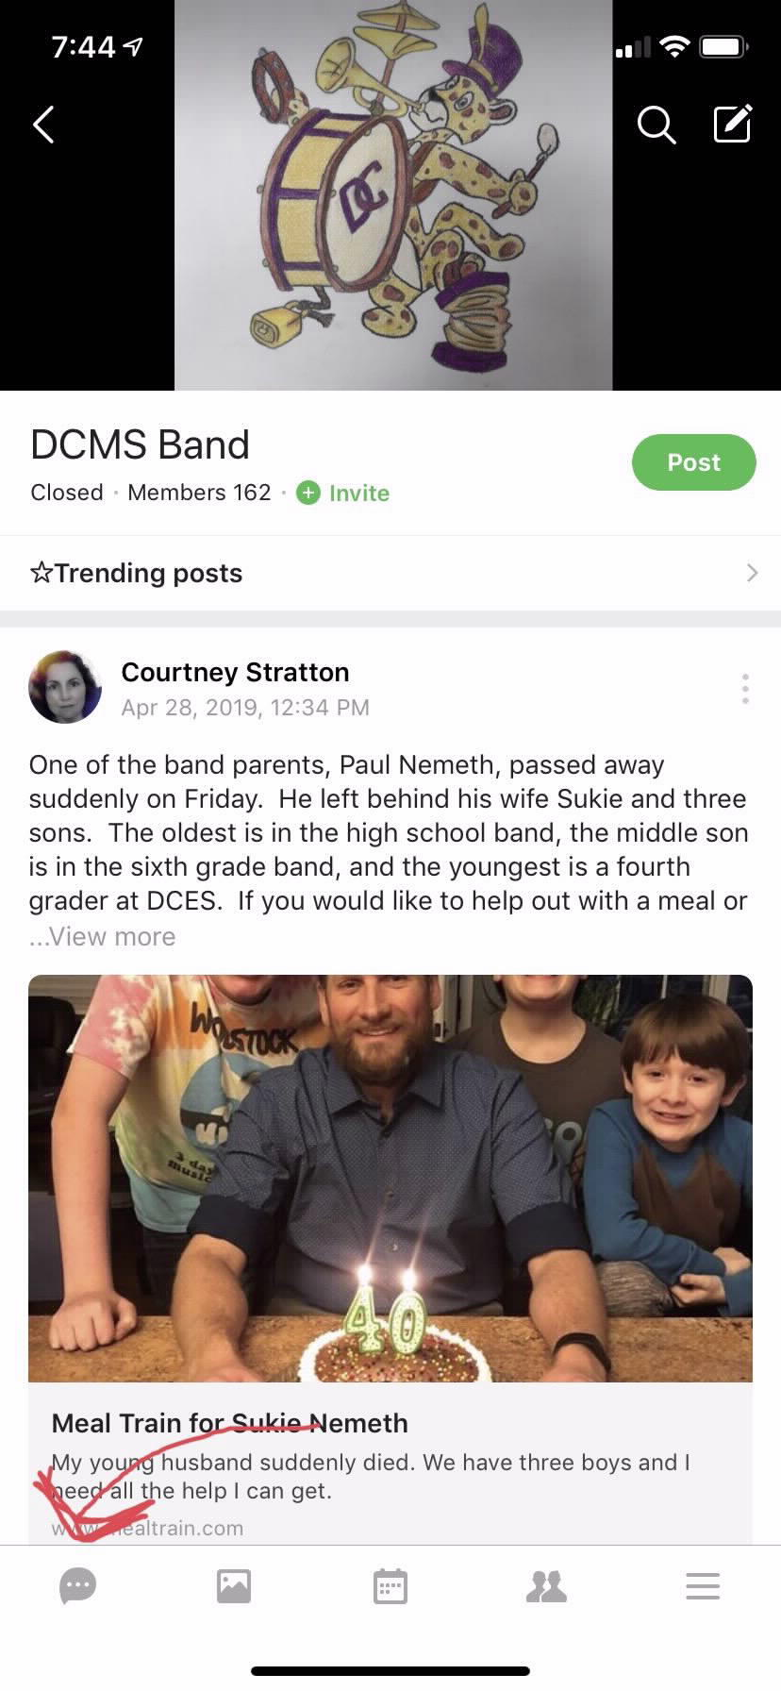
- Click the message bubble in the bottom left hand corner, which takes you to our chat rooms. There are many chat rooms to subscribe to for various updates. You can subscribe by just clicking on the chat. We have tons of volunteer committees to join to help keep our band program running in tip top shape. You must sign up for the following:
  - Your respected grade level “5th Grade Parents,” “6th Grade Parents,” “7th Grade Parents,” or “8th Grade Parents.”
  - DCMS Band
  - Important Documents
- New parents (incoming 6th graders) may also wish to sign up for the New Parent Buddies, where you can ask questions about being a band parent to veteran parents.

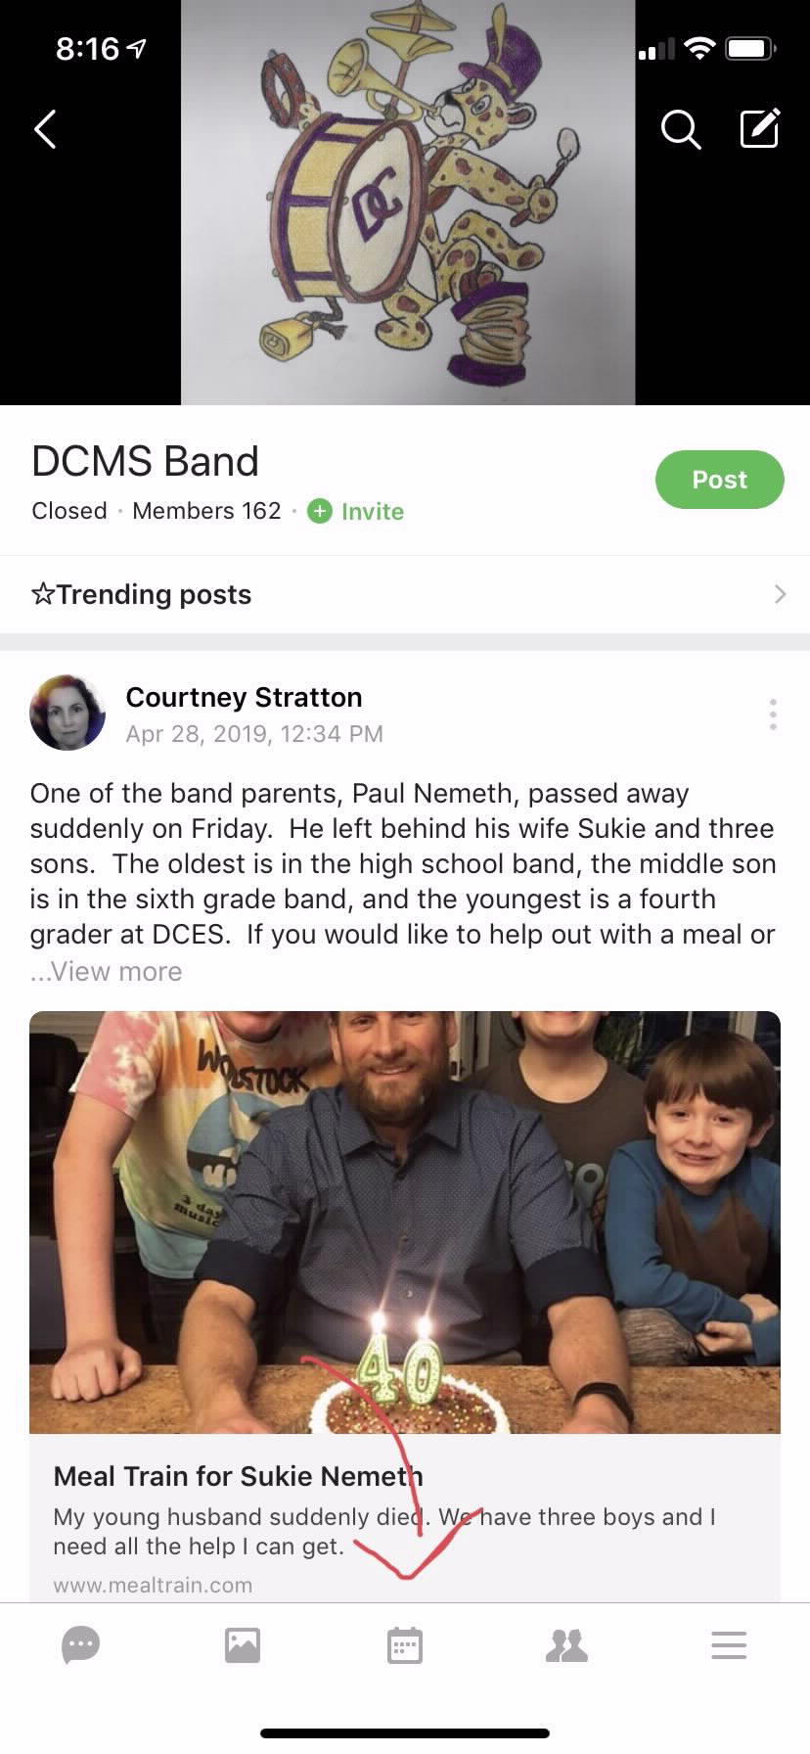
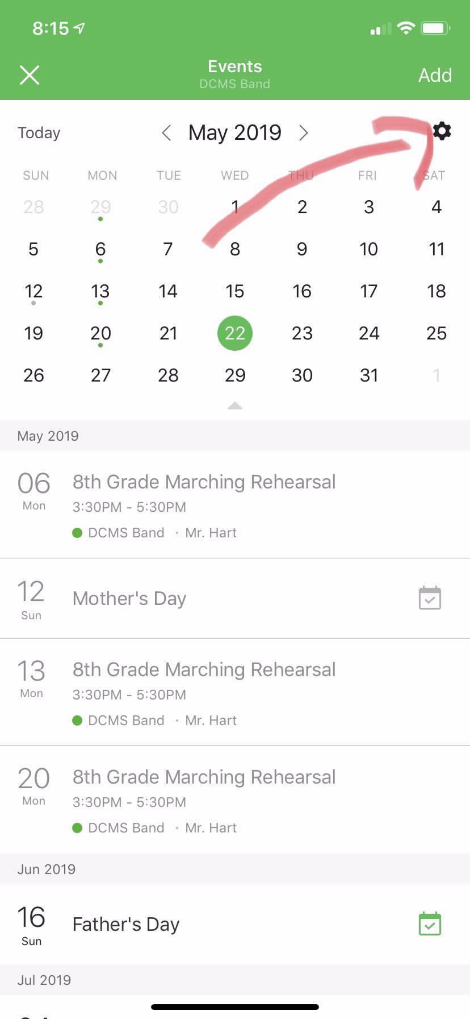
- Exit out of the chat window.

- At the bottom, you can also click on albums to check out pictures

- Click the middle button on the bottom to access our calendar. I highly recommend that you subscribe to the calendar. To do this:
  - Click the settings icon
  - Click export band events
  - Click DCMS Band
  - You can now select to add this to your calendar or copy the URL for a desktop
- If you have further questions, hop in the chat and ask a member

